Build a modern software agency website called “DevDuo” with a simple and beginner-friendly backend system.
Project Concept:
DevDuo is a software/web development agency run by two developers:
- Furqan Ali
- Faizan Ali
The business model is:
We will scout businesses and brands that have good potential but do not yet have a professional website. We will cold email those businesses and invite them to work with DevDuo.
The website should work as:
- A professional portfolio website
- A place where potential clients can contact us
- A platform where clients can register after confirming a deal
- A simple client portal where they can track project progress
Important:
Keep the backend simple, clean, beginner-friendly, and easy to understand. Do NOT build an overly complex SaaS platform.
Main Features Required:
- Modern Agency Website
Create a premium modern frontend for DevDuo with these sections:
- Hero Section
- Services Section
- Portfolio / Selected Work
- Team Section
- Testimonials
- About Us
- Contact Section
- Footer
Design Requirements:
- Modern software agency aesthetic
- Premium but minimal UI
- Smooth animations and transitions
- Fully responsive design
- Clean typography and spacing
- Portfolio & Team Profiles
The portfolio section is extremely important because clients may want to see our work before hiring us.
Create professional profile cards for:
- Furqan Ali
- Faizan Ali
Each profile card should include:
- Profile image
- Short bio/introduction
- Skills/technologies
- GitHub profile link
- LinkedIn profile link
- “Hire Me” button
When a visitor clicks “Hire Me”:
- Open a contact form or inquiry modal
- Allow the client to directly contact that specific developer
The portfolio section should showcase:
- Previous projects
- Project previews/images
- Technologies used
- GitHub repository links
- Live demo links (if available)
- Client Contact System
The website should include:
- Contact form
- Direct email contact button
Potential clients should be able to:
- Contact DevDuo directly
- Ask for project quotations
- Discuss project requirements
When someone submits the form:
- Save inquiry data in MongoDB
- Send the inquiry to DevDuo admin email
- Send an automatic confirmation email to the client
Contact form fields:
- Full Name
- Email
- Business Name
- Project Description
- Budget (optional)
- Client Registration & Login
After a deal is confirmed:
- Clients can register/login to the DevDuo platform
- Each client should have access only to their own dashboard
Authentication should remain simple:
- JWT Authentication
or
- Session-based Authentication
- Simple Client Dashboard
Each client dashboard should display:
- Project Name
- Project Status
- Progress Percentage
- Deadline
- Latest Updates
- Notes/Requirements shared by DevDuo
Project statuses:
- Pending
- In Progress
- Testing
- Completed
Purpose:
This is NOT meant to be a complicated project management system.
It should simply help clients professionally track their project progress.
- Simple Admin Dashboard
Create a clean and beginner-friendly admin panel where DevDuo admins can:
- View client inquiries
- Add new projects
- Assign projects to clients
- Update project progress
- Change project status
- Add updates/notes for clients
Keep the admin panel simple and easy to manage.
- Recommended Tech Stack
Frontend:
- React.js or Next.js
- Tailwind CSS
- Framer Motion (optional)
Backend:
- Node.js + Express.js
Database:
- MongoDB
Authentication:
- JWT Authentication
Email Service:
- Nodemailer
- Development Instructions
- Keep code clean and beginner-friendly
- Use reusable React components
- Use simple folder structure
- Avoid unnecessary backend complexity
- Focus heavily on frontend quality and UI/UX
- Add proper form validation
- Use protected routes for dashboards
- Write scalable but easy-to-understand code
Final Goal:
The final DevDuo website should feel like a modern premium software agency platform where businesses can:
- View our portfolios
- Visit our GitHub and LinkedIn profiles
- Hire Furqan Ali or Faizan Ali directly
- Contact DevDuo professionally
- Register as clients
- Track their project progress through a simple dashboard system

IMP NOTE:

“Listen first fully polish and make the changes that are required to make the frontend UI look complete and perfect ok”

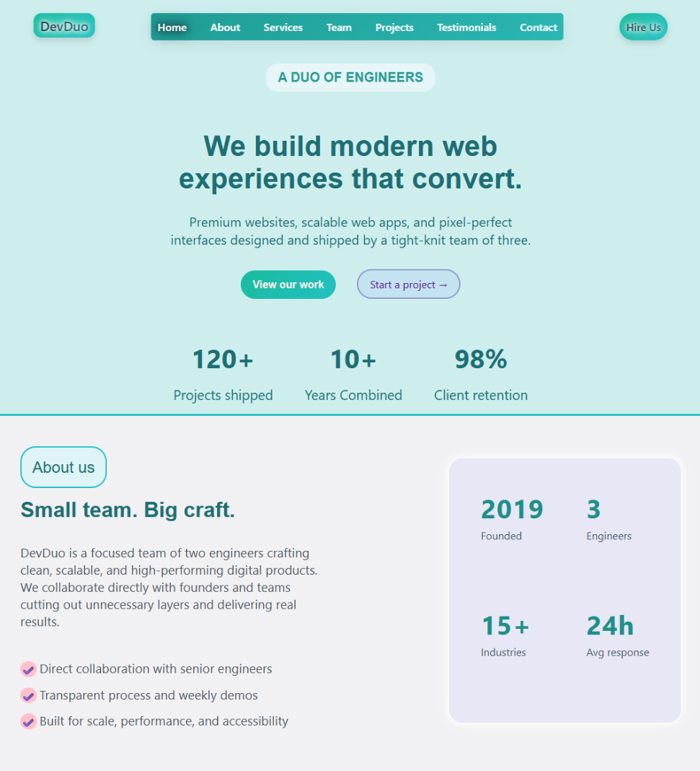
i have made this on my own and a bit help from u also
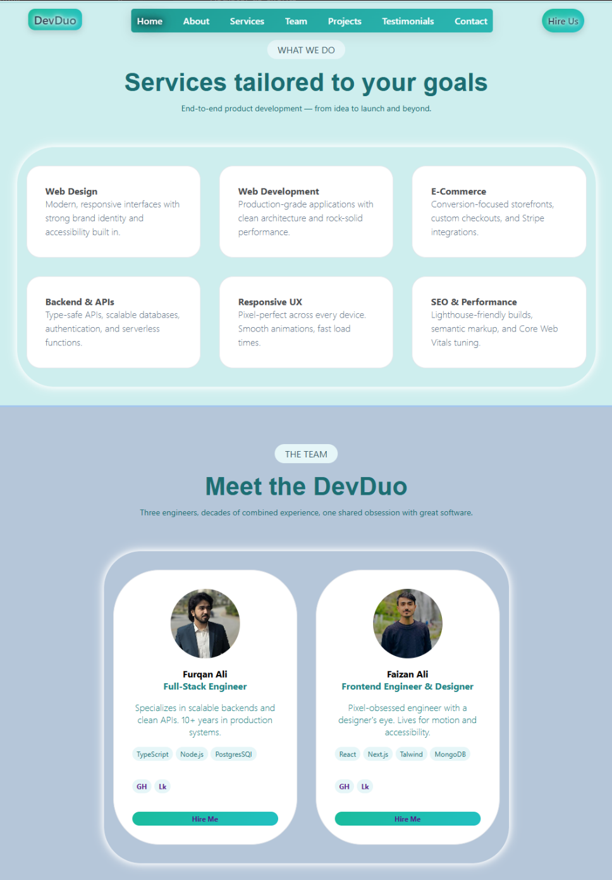
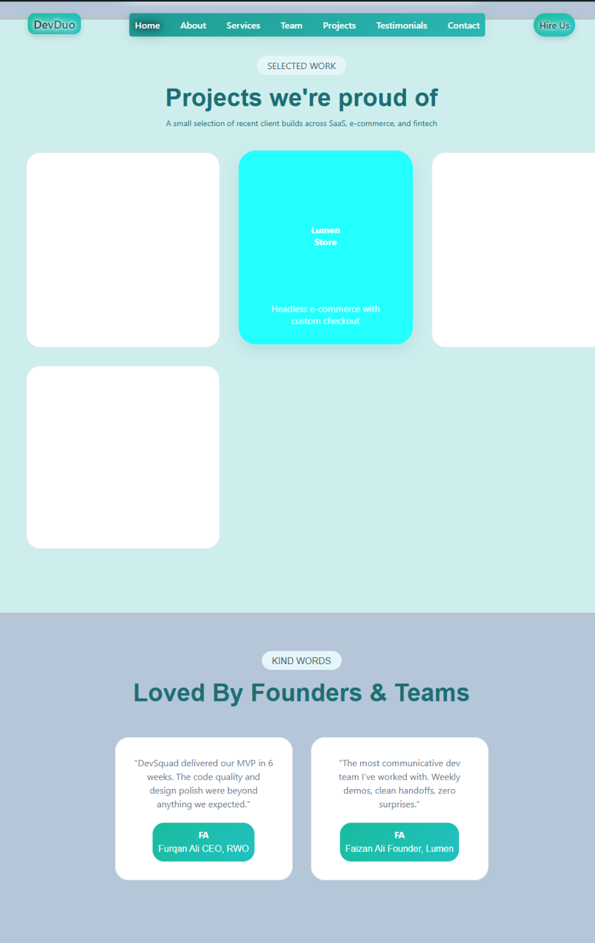
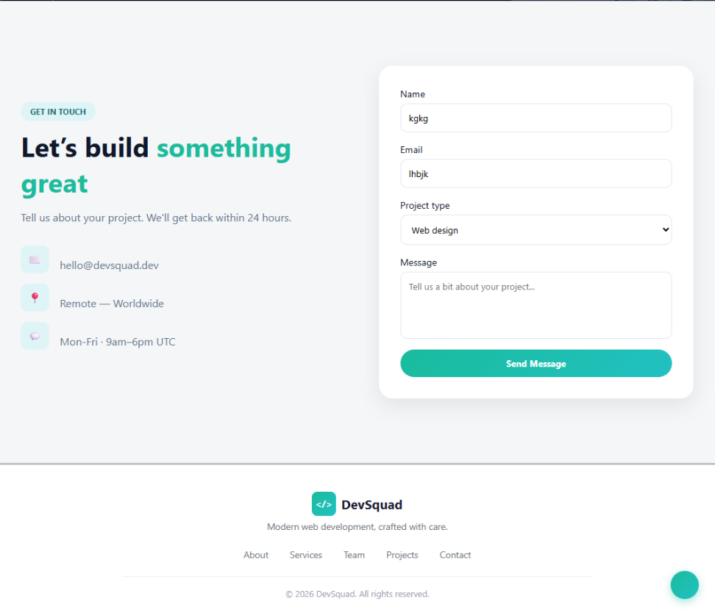

Detailed Improvement List for Your DevDuo Website
Your foundation is already strong.
Now the goal is to move from:
“Good student frontend” → “Professional agency-quality frontend.”

1. NAVBAR IMPROVEMENTS
Your navbar is already clean, but these changes will make it premium.

Changes to Make

A) Add Sticky Navbar
When scrolling:
- navbar stays fixed on top
- add slight blur effect
- reduce navbar padding slightly on scroll
Example effects:
- backdrop-filter: blur(10px)
- background: rgba()

B) Add Hover Animations
Currently links feel static.
Add:
- underline animation
- color transition
- slight upward movement
Example:
transition: 0.3s ease;
transform: translateY(-2px);

C) Active Link Indicator
When user scrolls:
- current section link becomes highlighted
Example:
- About active while on about section
This instantly feels professional.

D) Mobile Navbar
You MUST build:
- hamburger menu
- slide menu
- fullscreen mobile nav
Right now this is your biggest missing feature.

2. HERO SECTION IMPROVEMENTS
Your hero section is good already.
Now improve hierarchy and conversion.

Changes to Make

A) Improve Headline Width
Current heading is slightly too wide.
Use:
max-width: 700px;
This improves readability.

B) Add Better CTA Hierarchy
Currently both buttons feel equal.
Instead:
- primary button = filled
- secondary button = outline
Make:
- “Start a Project” the main CTA

C) Add Subtle Background Effects
Your hero background is flat.
Add:
- radial gradient
- blurred circles
- noise texture
- floating shapes
VERY subtle.
This creates depth.

D) Add Scroll Animation
Hero content should:
- fade up
- stagger animate
Example:
- badge first
- heading second
- paragraph third
- buttons fourth

E) Improve Stats Section
Current stats section feels disconnected.
Improve:
- add separators
- add hover animations
- animate numbers counting up
Example:
- 0 → 120+

3. ABOUT SECTION IMPROVEMENTS
This section already has good structure.
Now improve visual balance.

Changes to Make

A) Better Left/Right Alignment
Currently:
- left text area is visually heavier
Solution:
- reduce paragraph width
- increase spacing
- align card vertically

B) Add Icons to Features
Your checklist items need:
- proper icons
- aligned spacing
Use:
- Lucide icons
- Heroicons

C) Improve Stats Card
Current card feels empty.
Add:
- glassmorphism
- better shadows
- small divider lines

D) Add Team Image or Workspace Image
This section needs:
- visual storytelling
Example:
- coding desk
- team setup
- laptop workspace

4. SERVICES SECTION IMPROVEMENTS
Good structure.
Needs premium interaction.

Changes to Make

A) Add Hover Effects on Cards
On hover:
- move upward
- border glow
- stronger shadow
Example:
transform: translateY(-10px);

B) Add Service Icons
Each service should have:
- icon
- visual identity
Examples:
- monitor icon
- backend server icon
- SEO icon

C) Improve Card Spacing
Current cards feel slightly compressed.
Increase:
- padding
- line-height

D) Add Gradient Borders
This instantly upgrades design quality.

5. TEAM SECTION IMPROVEMENTS
This is currently your BEST section.
Seriously.
Now polish it heavily.

Changes to Make

A) Replace “GH” and “Lk”
Use actual icons:
- GitHub icon
- LinkedIn icon
This matters a lot visually.

B) Improve Profile Images
Current images are okay but:
- need cleaner crop
- consistent sizing
- better border
Add:
border: 4px solid white;

C) Add Hover Card Effect
On hover:
- scale card slightly
- image zoom
- shadow glow

D) Add Availability Badge
Example:
- Available for Freelance
- Open to Projects
Small detail → huge professional feel.

E) Improve Tech Stack Tags
Current tags are nice.
Improve:
- better spacing
- hover effect
- consistent sizing

F) Add Modal/Profile Popup
When clicking profile:
open:
- detailed profile
- experience
- portfolio
- social links

6. PROJECT SECTION IMPROVEMENTS
Currently this is your weakest section.
Needs realism badly.

Changes to Make

A) Add Real Project Thumbnails
Current blank cards look unfinished.
Add:
- dashboard screenshots
- landing page mockups
- device mockups

B) Add Project Information
Each card should contain:
- project name
- short description
- technologies used
- live preview button
- GitHub button

C) Add Hover Overlay
On hover:
show:
- buttons
- project details
- animation
Very modern effect.

D) Use Masonry/Grid Layout
Your current spacing feels uneven.
Use:
- CSS Grid
- equal height cards

7. TESTIMONIAL SECTION IMPROVEMENTS
Good structure.
Needs authenticity.

Changes to Make

A) Add Client Images or Logos
Right now testimonials feel fake.
Add:
- company logo
OR
- client avatar

B) Add Star Ratings
Simple:
⭐⭐⭐⭐⭐
Makes section more believable.

C) Improve Testimonial Cards
Add:
- hover effect
- better spacing
- quotation mark icon

D) Add Slider/Carousel
Instead of static cards:
- sliding testimonials
Feels more dynamic.

8. CONTACT SECTION IMPROVEMENTS
This section is already strong.
Just polish UX.

Changes to Make

A) Add Form Validation
Show:
- error messages
- success messages

B) Better Input Focus States
When user clicks input:
- border glow
- smooth transition

C) Add Loading State
When submitting:
- spinner
- disabled button
Very important.

D) Add Success Popup
Example:
“Your message has been sent successfully.”

E) Add Direct WhatsApp Option
This would help your business model A LOT.

9. FOOTER IMPROVEMENTS
Currently decent but basic.

Changes to Make

A) Add Social Icons
Add:
- GitHub
- LinkedIn
- Email

B) Add Small CTA
Example:
“Let’s build your next project.”

C) Add Better Visual Hierarchy
Currently everything blends together.

10. GLOBAL DESIGN IMPROVEMENTS
These changes affect ENTIRE website.

Typography
Use better font pairing.
Suggestions:
- Inter
- Satoshi
- General Sans
- Poppins

Spacing System
Create consistent spacing:
8px
16px
24px
32px
48px
64px

Border Radius Consistency
Some elements have different radius styles.
Standardize:
12px
16px
24px

Shadows
Current shadows are slightly outdated.
Use softer modern shadows:
box-shadow:
0 10px 30px rgba(0,0,0,0.08);

Animation System
Add:
- fade up
- stagger animations
- hover transitions
- scroll reveals
Use:
- Framer Motion
OR
- AOS library

11. RESPONSIVENESS (MOST IMPORTANT)
This should now become your MAIN priority.
You need:
- mobile navbar
- stacked cards
- proper mobile spacing
- responsive typography
- tablet layouts
Without responsiveness:
clients won’t take it seriously.

12. BUSINESS IMPROVEMENTS
These are VERY important for conversion.

Add “Process” Section
Explain:
- Contact Us
- Discovery Call
- Development
- Delivery
This builds trust.

Add Pricing Starting Point
Example:
“Projects starting from $500”
Filters unserious clients.

Add FAQ Section
Answer:
- timelines
- pricing
- revisions
- support

Add Calendly Integration Later
Clients can book meetings directly.

PRIORITY ORDER (MOST IMPORTANT)

Phase 1
- responsiveness
- typography
- hover effects
- portfolio realism

Phase 2
- animations
- microinteractions
- improved cards

Phase 3
- backend
- dashboard
- authentication
- client portal

